GRAPHIC USER INTERFACE (GUI)

HOME PAGE:

The home page allows the users to interact and to get more familiar with application. The users can search for event, activities, and book transport and adult learning University.

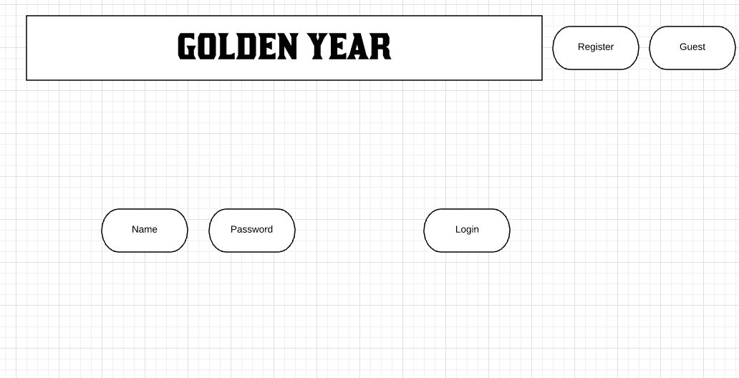

User Registration:

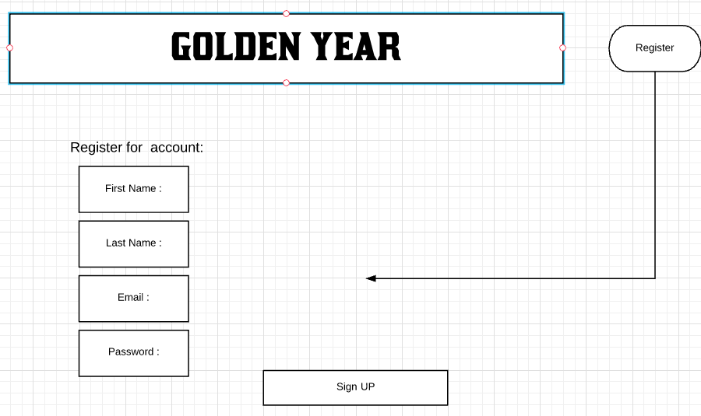

The register button brings you to another page for user to sign up for a free account.

To register the user is required to input their first name, last name, email address and the password. A prompt message will show up on the users screen to confirmation their email address.

Once the email has been verified, by following the link send to user’s personal email, the link will take the users back to the page to log in.

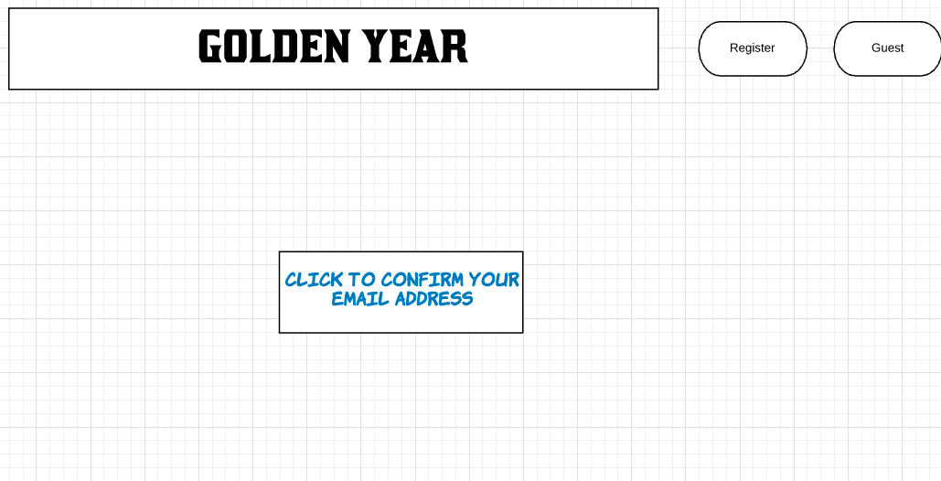

once the email is confirmed, the user will be taking to a page where they can access all the information on the web application.

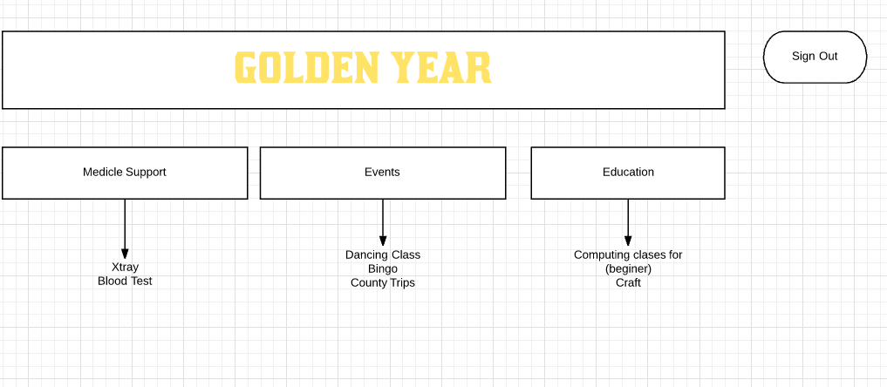

The login box allows the users to input their name and

password to gain access to the main page once they are already a registered. Once the login is approved, the user will be taking to the main page of the web application.

Guest users also have access to the main page. Guest users have options to register or not.

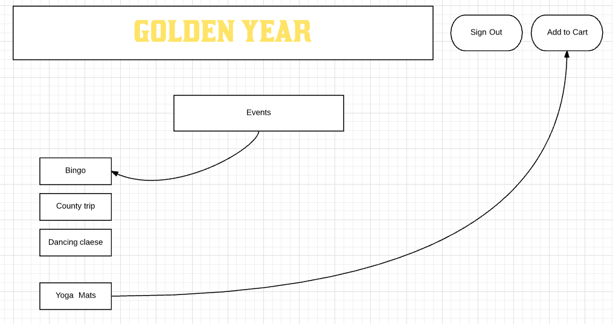

The event button brings the users to another page where they can choose what activities they will like to attend. The cart allows users to add those activities, by clicking on the button that says add to cart.

**PAYMENT:**

A prompt box will be displayed on the user’s screen for the user to grants access to proceed to checkout.

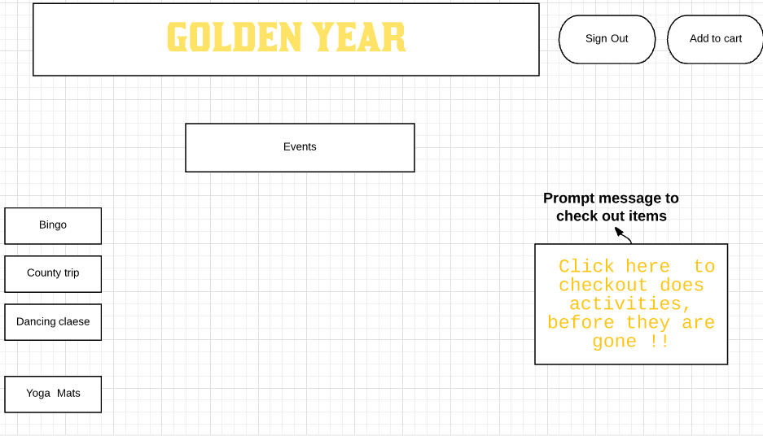

Payment:

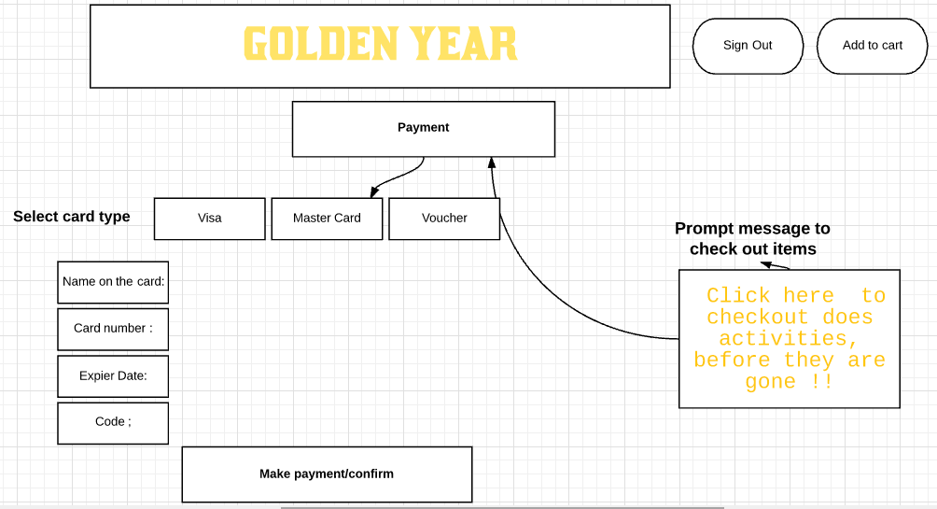

By clicking on the prompt message, the users will be taking to a page where the user will be required to choose the payment type. Then the name on the card, card number, expire date and security code. A button to make payment/ confirmation will be available to click by the users.

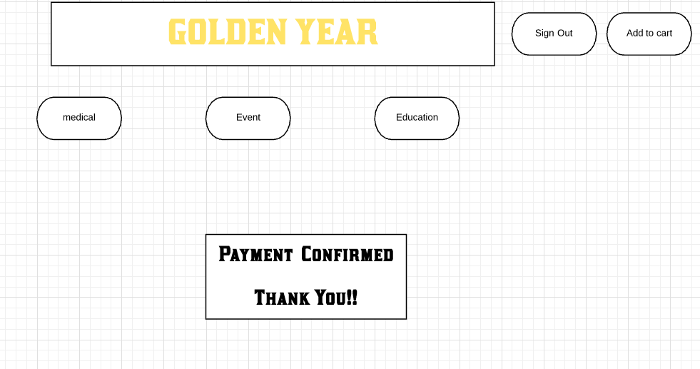

Once the payment has been made, there will be a prompt massage that says payment confirmed.